Design Document and Test results

Members of the team:

R Kartik Naiker -- h20181030102
Surajit Dutta Gupta -- h20181030108
Raj Bakulbhai Joshi --h20181030101

Version no | Change Made By | Description | Date
0.1 | Raj | Initial Draft | 15/10/18
0.2 | Karthik | Changes for CUR model | 20/10/18
1.0 | Surajit | Final changes after code change for CUR and SVD | 29/10/18

List of Contents

Page no | Content
1 | Application Architecture
1 | Data Structures used
3 | Preprocessing of data
3-5 | Functions used
5-6 | Standard formulas
7 | Important approximations used
7-10 | Runtimes and sample test case
10 | Table filled as given in assignment

Application Architecture
We have modeled a recommendation engine on the basis of dataset of movies vs users.The data set contains around 1000 X 1700 dataset (user X movies).The data is essentially taken from website, “https://grouplens.org/datasets/movielens/” .There are three separate csv files containing data which is saved as objects using pickle module.We have separate python files which are used to create collaborative,svd and cur models for recommendation.Also we have associated main files which contains the driver program to run the different functions.Data is saved using csv files and pkl object files.The size of data in disk is approximately 1 Mb.

Data Structures/Packages used
Classes are used to generate movie class and ratings class.Objects are created and saved in serialized manner using pickle module.Other than that we have extensively used numpy ndarray,list,dictionary and dataframes.
The below standard packages are used:
- pandas
- numpy
- scipy
- math
- collection
- pickle
- random
- operator
Eigenvalues and eigenvectors are calculated using scipy or numpy packages.All core functionality
for collaborative,svd and cur are done by us.

Preprocessing of data
Three csv files of data mentioned below were first saved as pickle object files under ‘objects/test100’ folder
- dataset/test100/movies.csv
- dataset/test100/ratings1_base.csv
- dataset/test100/ratings1_test.csv
Main methods of each module will first load from these object files created under objects folder and then will convert the data into matrix form before processing further.Data is stored as 2d numpy arrays.After the initial processing all data manupulation is done on the arrays.

Functions used
For collaborative filtering the below files and functions are used:
calc_rating.py -- This is used for calculating specific user rating for a given userid and movie id.This file contains the below mentioned functions
1) calculate_cf(load_matrix, movie_num, user_num) --calculates rating based on collaborative filtering
2) calculate_cfbl(load_matrix, movie_num, user_num)--calculates rating based on cf with baseline approach
cf__rmse_topk_corr.py – This is used to calculate errors and other evaluation parameters for collaborative filtering.Here RMSE,spearman corr coeff and precision at top k is found for collaborative filtering.
cfbl__rmse_topk_corr.py – This is used to calculate errors and other evaluation parameters for collaborative filtering using baseline approach.Here RMSE,spearman corr coeff and precision at top k is found.
specific_user.py – This is used for taking user inputs for calculating rating
main.py – driver program.

For SVD approach the below files and functions mentioned are used:
svd_recommender.py – This file contains all functions required for svd operation.Functions are mentioned below.
svd(ratings_array,concepts) – This function is used to calculate svd decomposition.It takes parameter as the array for svd and the no of target concepts to break into.(Min of size of row or column is passed as concepts by default).This will return matrix U sigma and V.
predicted_matrix (ratings_array,concepts) – This functions calculates inner product of U sigma and V transpose.It returns constructed matrix and square difference mean from original matrix and this constructed matrix.
ratings_users (ratings_array,concepts,userid) – This function calculates user to concepts projection.
ratings_movies (ratings_array,concepts,movieid) – This function calculates movies to concepts projection.
check_energy_retained(ratings_array,concepts,concepts_to_check) – This function calculates how much energy is retained given two concepts.This function is NOT called in main program and our recommendation engine.
svd_with_ninty_percent_energy(ratings_array,concepts) – This function calculates the predicted matrix decreasing concepts from given concepts retaining almost 90% energy.This function returns the predicted matrix and also returns square difference mean from original matrix and this constructed matrix.
energy_ninty_percent(ratings_array,concepts) -- This function tries to lower down concept size till 90% energy is retained.It find the concept size till less than 90% is reached.
lower_concept(eigenvalues,concepts,frob_norm,energy) – Recursive method to find the actual concept size for energy_ninty_percent.
calculate_rmse(test_matrix,predicted_matrix) – Calculates rmse between test matrix (test+base) and constructed matrix.
spearman_rank_correlation(test_matrix,predicted_matrix) – Calculates spearman rank correlation between test matrix and constructed matrix.
precision_at_top(test_matrix,predicted_matrix,k,userid) – Calculates precision at top k between test matrix and constructed matrix
main.py – driver program for svd.

For CUR approach below files are used
cur_decomposition.py – This contains all logic for CUR decomposition.Below are the functions used in this file.
cur_create(flag) – This contains logic for CUR decomposition.Flag 0 is for normal CUR and flag 1 is for CUR with 90% energy case.Both call to cur with flags are placed inside the file.
main.py – same file as in collaborative case.This is used to create base matrix and test matrix from pickle object.

Standard Formulas used
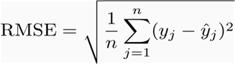
Root mean square error :

Where yj is the test ratings matrix and yj bar is the predicted ratings matrix corresponding array elements.The elements of difference matrix is squared and mean is taken over all elements of the array and square root taken over it.

Spearman correlation coefficient:
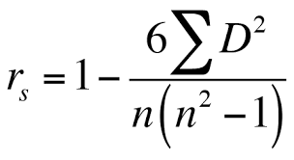

Where D is the difference matrix of corresponding elements of test ratings matrix and predicted ratings matrix.Each element of the difference matrix is squared and sum is taken.Here n represents no of ratings.

Precision at top k:
Precision@k = (# of recommended items @k that are relevant) / (# of recommended items @k)
for taking relevance we have converted ratings into binary model where rating greater than some value is taken as relevant for a user.For collaborative we have assumed it as 3,while for svd of cur we have taken it as 1.We have found for given k how many are recommended (i.e above threshold rating) from the predicted matrix and how many are relevant from the test matrix.Then we have taken the intersection and a ratio is taken.f
for eg.
item/actual/predicted
item7/2/4.9
item5/5/4.5
item10/4/4.3
item2/2/3.6
item2/3/3.4
item1/4/2.3
The number of relevant items are the items with actual rating greater or equal to 3.5.(here threshold is 3.5 and k is 3)
Relevant items: item5, item10 and item1
total # of relevant items = 3
Recommended items @ 3
The recommended items at 3 are item7, item5 and item10
Recommended items @ 3: item7, item5 and item10
# of recommended items at 3 = 3
Recommended and Relevant items @ 3
It is the intersection between Recommended@3 and Relevant@3 which are
Recommended@3 INTERSECTION Relevant: item5 and item10
# of recommended items that are relevant @3= 2
Precision@3
=(# of recommended items that are relevant @3)/(# of recommended items at 3)
= 2/3
= 66.67%

Important approximation used
For collaborative filtering ratings equal to 0 and below it are converted to 1 and above 5 is kept as 5.This way we have somewhat scaled the scores so that it never crosses the range.No such scaling have been applied in SVD and CUR as we are not exactly sure how to properly scale the ratings after the decomposition and multiplication as some ratings have dropped and some have become negative.
Approximate rounding is done is some places.
For collaborative filtering we have used top 2 neighbours based on similarity rating.
For CUR decomposition we have taken almost 70% of the rank of the matrix.

Runtime and sample test case
We did not have a specific test case to run.We have run taking some examples and checking the output of RMSE,correlation coeff and precision scores.Below are the screenshots attached.
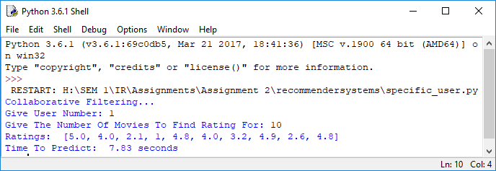

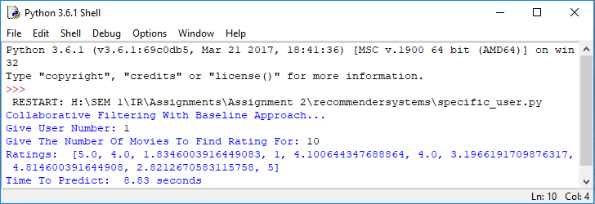
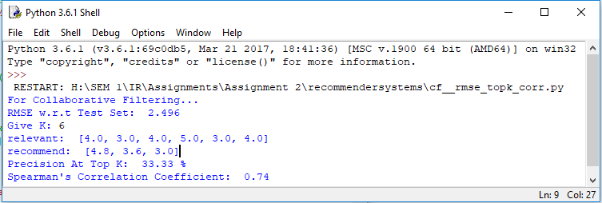
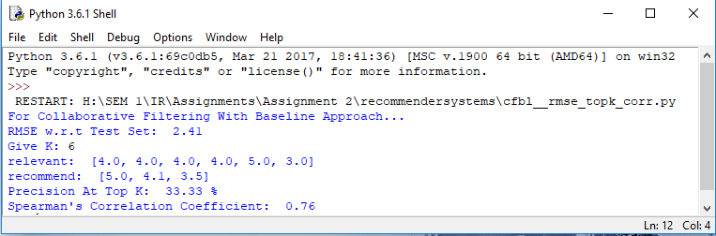
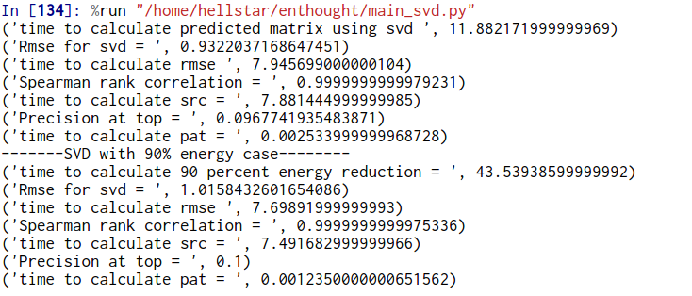

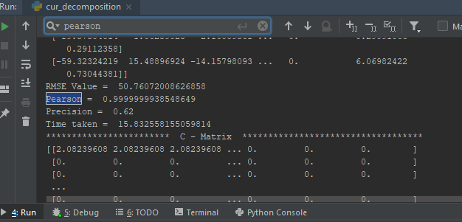

With 90% energy retained
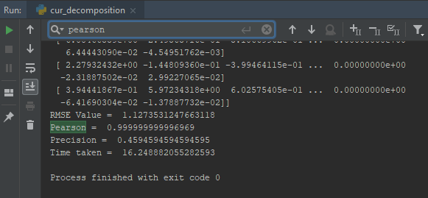

Table as given in assignment:
For sample run we got the below results.(The value of userid and k used is different for different models.)
Recommender System | RMSE | Spearman Correlation coeff | Precision at top k | Time taken
Collaborative | 2.49 | 0.74 | 0.33 | 7.83 sec
Collaborative with baseline | 2.41 | 0.76 | 0.33 | 8.83 sec
SVD | 0.93 | 0.99 | 0.09 | 11.882 sec
SVD with 90% energy | 1.01 | 0.99 | 0.1 | 43.53 sec
CUR | 50.76 | 0.99 | 0.62 | 15.83 sec
CUR with 90% energy | 1.127 | 0.99 | 0.45 | 16.24 sec

